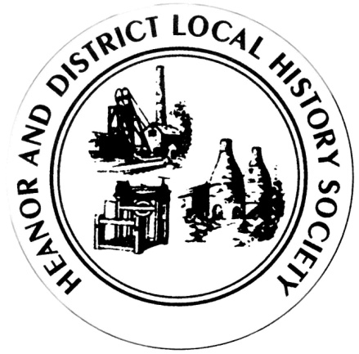
We want your memories! As part of an ongoing project, the Heanor & District Local History Society wants to hear from YOU.
We would like to establish a collection of people’s memories about the area - it can be from any period, and from any part of the district. And ANY subject - whether home life, work life, shopping, leisure. It doesn’t matter how trivial you may think your reminiscences are, they will help form part of a much bigger picture, which we can use to assist our future research, publications and newsletters.
This is nothing new of course; we have always asked for this from our members, but have now decided to use this method to try to prompt people to give information on specific issues.
So, every couple of meetings (if it works), we will distribute a new form, on a different topic, and with different questions. There is no deadline. You don’t have to take part in all, or any, of the topics. Likewise, you don’t have to be a member to take part - all that we ask is that it is something to do with the Heanor area, or involved Heanor people. If you can think of someone else who may like to help, please feel free to pass a form onto them.
This month’s topic is: A Walk in the Country.
How to pass the information onto us:
- If you normally attend our meetings, just fill in the form and hand it back at the next meeting.
- If you don’t attend our meetings, then please send us an email with the information (mail@heanorhistory.org.uk).
We would rather that you didn’t send us information anonymously, but nobody’s name will be published unless you have specifically given us permission to do so. In particular, we WILL NOT publish anything which of a personal or potentially sensitive nature.
Name | Address
Telephone
Email address
Are you willing for your name to be linked to any information supplied? |  | Yes / No
Would you be prepared to discuss this or related information further? |  | Yes / No

P.T.O.

We want to examine the relationship between people and the countryside which surrounds the Heanor area in the past.
Try to think back to a specific period of your life when answering these questions.
Did you have a favourite country walk - if so, where did you go?
From roughly when do you recall it?
Did you have any specific reason for going there?
Who did you used to go there with? Was it on a specific day of the week/time of year?
Describe what you remember of the countryside.
What can you remember about the sights and sounds as you walked? What is your favourite memory?
Was there a particular vantage point on the walk - what could you see?
How has the area changed now?
Please use a separate sheet if necessary.
If you would like to repeat the questions for another area, please do so on a blank sheet.
Thank you

